Ch 9: Two-Level Longitudinal Data

**Case study: Charter Schools**

Use the TwoLevelLongitudinal.rmd file to help answer these questions.

1. Based on the EDA, what seem to be key factors associated with higher math scores? Did you notice other important trends in the EDA plots and tables?

2. What are pros and cons of lattice plots vs. spaghetti plots?

3. Why is it sensible that the correlation between slopes and intercepts for individual schools is negative?

4. Does the effect of charter schools seem to depend on the percent free and reduced lunch students at a school?

5. What is the intraclass correlation coefficient based on the unconditional means model? What does that say about the effective sample size in this case study?

6. Model D2 in the R script is featured as Model D in BYSH Section 9.6.2.

* What are the implications of charter:year08 being significant and positive?
* What are the implications of SchPctFree:year08 being significant and negative?

7. Model F2 in the R script is featured as one potential final model in BYSH Section 9.6.3.

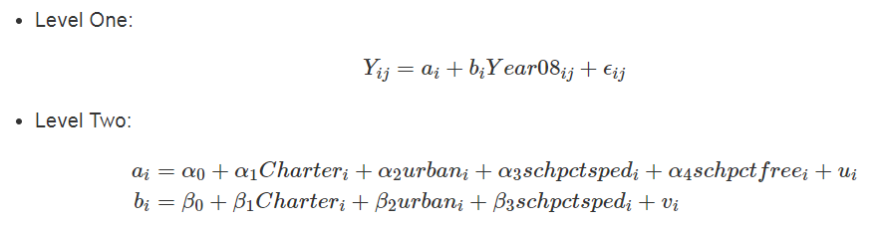

* How does the effect of charter schools in this model compare to the effect we saw in Model C (uncontrolled effects of school type)? Carefully interpret $α_{1}$ and $β_{1}$ in context.
* What can you say about schools with higher levels of poverty (as measured by percent free and reduced lunch)?
* We claim that “the 2008 gap between charter schools and public non-charter schools was consistent across demographic subgroups. The faster improvement between 2008 and 2010 for charter schools was also consistent across demographic subgroups.” What terms were tested in modeling to support this statement?

8. If we want to test whether or not adding random effects improves our model, a parametric bootstrap test is typically more reliable than a likelihood ratio test, since we are testing values along a boundary constraint. Use the process outlined below to describe how a parametric bootstrap works in this instance to test whether $ρ_{uv}=0$ in Model F2. Then determine the first 3 observations in the first bootstrap data set with set.seed(13). **This will require that you write your own code!**

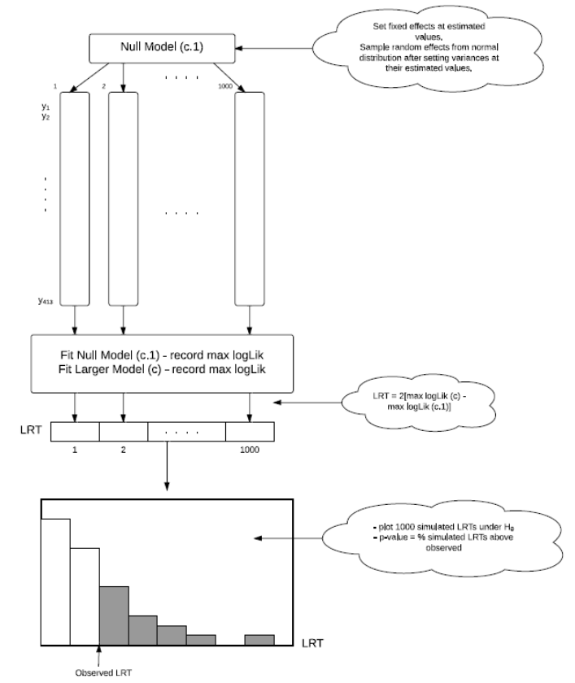

9. As detailed in BYSH Section 9.7.1, our standard two-level multilevel model implies a specific within-school covariance structure – our 4 estimated variance components determine all 6 variance components within a school (1 variance term for each of the 3 time points, and 3 correlations for the 3 pairs of time points). Describe:

a) the difference between the Level Two covariance structure in our multilevel model and the covariance structure on observations within a school;

b) the implied features of the within-school covariance structure based on our two-level model